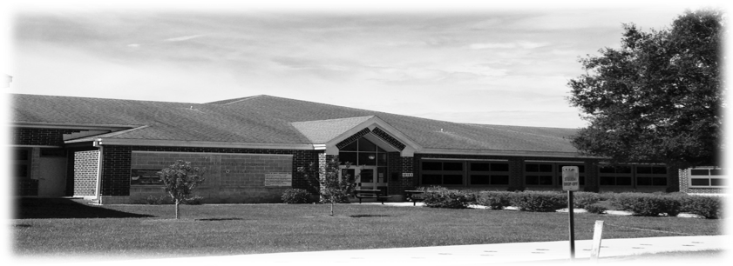

**Macclenny Elementary School**

One Wildkitten Drive

Macclenny, Florida 32063

Lynn T. Green, Principal Phone: (904) 259-2551

Dr. Rachel West, Assistant Principal Fax: (904) 259-5171

August 9, 2022

Dear Parents and Families,

As you may be aware, there is a nationwide shortage of school bus drivers, and this issue has impacted the Baker County Transportation Department. Our Transportation Director, Mrs. Pam Taylor, and her amazing staff have gone above and beyond to ensure that all routes are covered and our students will arrive to and from school safely and in a timely manner.

However, we have a shortage of substitute drivers. This means that when a driver is absent and unable to drive his/her route, there are no substitute drivers on standby to drive for them. Other bus drivers will need to drive a double route to pick up the absent drivers’ students as well as their own. As you can imagine, this will mean that bus pick-up and drop-off times will vary by as much as twenty minutes or more.

In order to help our families plan when their child’s driver is absent, our district will be utilizing our BlackBoard Communications System to send text messages, emails and phone calls to students’ primary phone numbers to inform families if their child’s bus will be early or late, and whether their child will be temporarily transported by a different bus. Our district will also use school social media sites, such as Facebook, school websites, etc., for additional transportation updates.

Since we will be communicating via phone, it is urgent that we have up-to-date contact information, i.e. phone number, address, etc. Accurate yellow cards are crucial to help us keep families informed. We also encourage families to utilize Live Bus Routes, found on our school websites. This app allows families to see any bus on its route in real time.

We ask for your patience and cooperation as we face this situation together. Your child’s safety is our top priority, and our district will work diligently to provide reliable transportation that Baker County School District families can trust.

If you are interested in the rewarding occupation of a school bus driver, please contact Mrs. Pam Taylor at 904-259-2444, and she can provide you with the criteria and training necessary to join our Baker County Transportation Team! We love and appreciate our drivers for their dedication, dependability, and love for children.

Sincerely,

Lynn T. Green, Principal